Topic: IPv4 addresses

**Objective:**

Implementing a code to display the class of IP address, network mask and generate the subnet IP address based on the subnet bits entered from the keyboard.

**Problem Statement:**

Displaying the class of IP address, network mask and generate the subnet IP address based on the subnet bits entered from the keyboard.The client or host address and the server or network address are the two halves of every device's IP address. Either a DHCP server or a human being can manually configure IP addresses (static IP addresses). The subnet mask separates the IP address into host and network addresses, indicating which portions belong to the device and which portions belong to the network.

**Algorithm:**

* For determining the class: The idea is to check the first octet of the IP addresses.
* As we know, for class A first octet will range from 1 – 126, for class B first octet will range from 128 – 191, for class C first octet will range from 192- 223, for class D first octet will range from 224 – 239, for class E first octet will range from 240 – 255.
* For determining the Network and Host ID: We know that Subnet Mask for Class A is 8, for Class B is 16 and for Class C is 24 whereas Class D and E are not divided into Network and Host ID.
* Here user will input the IP address and get which class it belongs to and get network and host address. According to class subnet mask is printed.

**Code:**

def findClass(ip):

if (ip[0] >= 0 and ip[0] <= 127):

return "A"

elif (ip[0] >= 128 and ip[0] <= 191):

return "B"

elif (ip[0] >= 192 and ip[0] <= 223):

return "C"

elif (ip[0] >= 224 and ip[0] <= 239):

return "D"

else:

return "E"

def separate(ip, className):

# for class A network

if (className == "A"):

print("Network Address is : ", ip[0])

print("Host Address is : ", ".".join(ip[1:4]))

print("Subnet Mask: 255.0.0.0")

# for class B network

elif (className == "B"):

print("Network Address is : ", ".".join(ip[0:2]))

print("Host Address is : ", ".".join(ip[2:4]))

print("Subnet Mask: 255.255.0.0")

# for class C network

elif (className == "C"):

print("Network Address is : ", ".".join(ip[0:3]))

print("Host Address is : ", ip[3])

print("Subnet Mask: 255.255.255.0")

else:

print("In this Class, IP address is not divided into Network and Host ID")

print("Subnet Mask: Not applicable")

if __name__ == "__main__":

ip = input('Enter IP address : ')

ip = ip.split(".")

ip = [int(i) for i in ip]

# getting the network class

networkClass = findClass(ip)

print("Given IP address belongs to class : ", networkClass)

# printing network and host id

ip = [str(i) for i in ip]

separate(ip, networkClass)

**Output:**

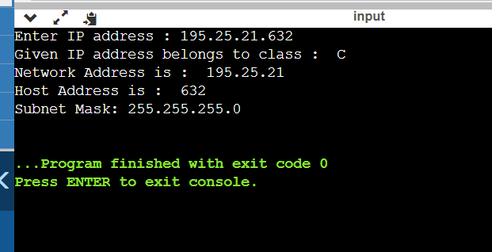

Given input is 195.25.21.632. The value ranges from 192 to 223 so it belongs to class C. IP address is the combination of Network address and Host address. As we know IP address is 195.25.21.632. Here, Network address is 195.25.21 and Host address is 632.

**Problems Faced:**

Initially, I found difficulty understanding the process behind the subnet IP address. Finally, I tried to solve the problems.

**Conclusion:**

With the help of this problem, I understood the concept behind subnet IP address. I learned how to implement the algorithm using the python language.